Project Report on



Submitted to

**JAYSHREE PERIWAL HIGH SCHOOL**

**3, Chitrakoot Scheme**

**JAIPUR**

In partial fulfilment of

the requirements for

**All India Senior School** **Certificate Examination 2018**

of

**Central Board of Secondary Education**

**SUBMITTED BY:**

SHREYA ATUL MUDGAL

PARTH SUYAL

VANSHIKA SOOD

**Acknowledgement**

We would like to thank everyone who helped in making this project successful.

We would like to thank our *family members* and r*espected teachers*, who helped and guided us with their support through the development phase of this project.

We are highly grateful to our project guide **Ms. Himanshi Sharma** for providing us her valuable guidance and support.

This task could not have been accomplished without the support of **Mrs. Jayshree Periwal**, ***Director*** and **Mrs. Madhu Maini**, ***Principal***, who provided us with a healthy and advanced computer lab.

**SHREYA ATUL MUDGAL**

**PARTH SUYAL**

**VANSHIKA SOOD**

**CERTIFICATE OF ORIGINALITY**

This is to certify that the project report entitled "***Quiz Program***" submitted to **JAYSHREE PERIWAL HIGH SCHOOL** in partial fulfillment of the requirement for **All India Senior School Certificate Examination (AIISSCE) 2018** of **CBSE**, is original work carried out by **SHREYA ATUL** **MUDGAL** under my guidance.

The matter embodied in this project is genuine work done by the students and has not been submitted by any course of study.

…............................

Signature of the Guide

Date: …....................

Name: **Ms. Himanshi Sharma**

JAYSHREE PERIWAL HIGH SCHOOL

JAIPUR

**CONTENTS**

|  |  |  |
| --- | --- | --- |
| S No. | TOPIC | PAGE No. |
| 1 | Objective & Scope of the Project | 2 |
| 2 | Problem Definition | 3 |
| 3 | Life Cycle of the Project | 4 |
| 4 | Details of Hardware and Software used | 6 |
| 5 | Input Screen Design | 7 |
| 6 | Source Code of the project | 17 |
| 7 | Data Dictionary | 33 |

**1. Objective & Scope of the Project**

**Objective**

The main objective of the project is to prepare a Airport Management System that presents the user to book and cancel flights.

This program is useful in maintaining *Airport system efficiently*.

**Scope**

This project is developed as a part of XII standard Course.

Further, it can be easily customized for large scale airport management since it can be easily edited to various cities and countries around the world.

**2. Problem Definition**

The project *“****AIRPORT MANAGEMENT SYSYTEM****”* offers the user to :

1. Reserve a Ticket
2. Cancellation a Ticket
3. PNR of a Ticket

**Reservation** presents the user with various flight choices and allows them to reserve a ticket according to their choice and pay for it. It can also be used to check the details of all the available flights. Moreover, user can also take a print out of their ticket .

**Cancellation** allows the user to simply cancel their ticket by entering their PNR NO.

**PNR** allows the user to check the status of their booked flight.

A developer is required to design the projects and adjust it as per the requirements. Suitable assumptions can be made during implementation. A proper normalized database is to be maintained in the RDBMS and the front end is to be developed using advanced interface controls. User-friendly interface is to be generated.

**3. Life Cycle of the Project**

**System Development Life Cycle (SDLC)**

The System Development Life Cycle (SDLC) is a set of activities that analysts, designers and users carry out to develop and implement an Information System.

The SDLC consists of the following activities.

**Feasibility Study**

**↓**

**Requirement Definition (Analysis)**

**↓**

**Design (Database &amp; Program)**

**↓**

**Development of Software**

**↓**

**Unit Testing**

**↓**

**System Testing**

**↓**

**Implementation**

**↓**

**Evaluation**

**↓**

**Maintenance**

**CONTEXT DIAGRAM**

## **Question Bank**

## **Player**

## **Administrator**

Add New Questions

Modify Questions

Add Questions

Get Score

Play QUIZ

Modify Questions

Check Answers

**4. Details of Hardware and Software used**

**Hardware Specifications**

Microprocessor (CPU) : i55200u

Memory (RAM) : 8 GB DDR3 1600 MHz

Virtual Memory : 64-bit

Hard Disk : 1000 GB HDD

VDU : HDMI

Keyboard : Inbuilt

Mouse : Inbuilt Keypad

**Software Specifications**

Operating System : Windows 10

Front-End Design :Python IDLE (3.7.8)

Back-End : MySQL

Documentation : Microsoft Word 2010

Version Control : GIT

**5. INPUT SCREEN DESIGN**

**INPUT FORMS**

**The Splash Screen:**

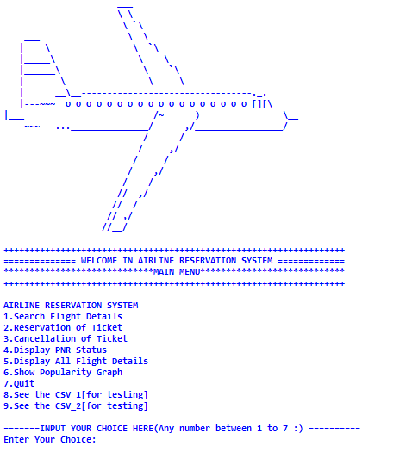

The user can enter any number of the options presented to them:

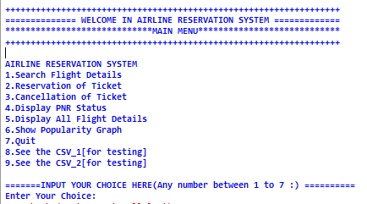

When the user chooses “1” they are presented with the choice to enter the source and destination cities which are then referenced from the database:

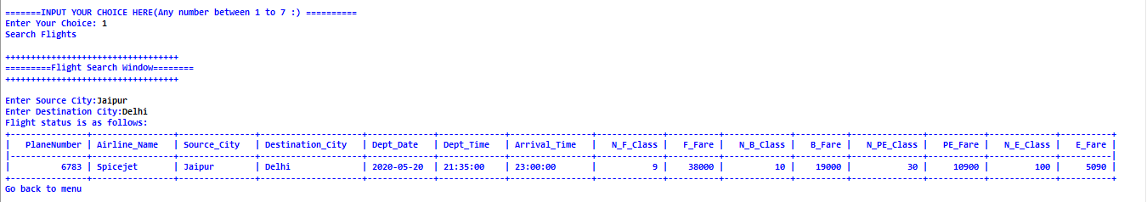

When the user chooses “2”they are asked to fill in following details and are presented with the total amount to be paid and a copy of the ticket:

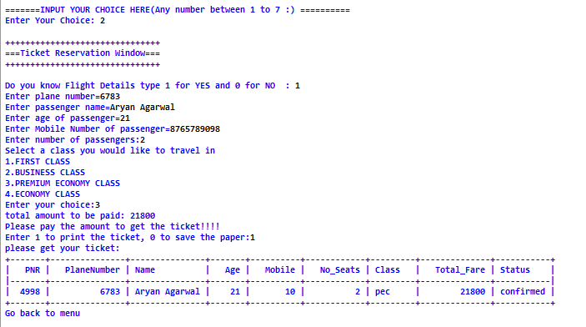

When the user chooses “3” they are asked for their PNR No. And their ticket is thus cancelled:

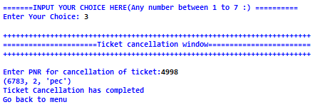

When the user chooses “4”they are asked for their PNR No. And their ticket is thus cancelled:

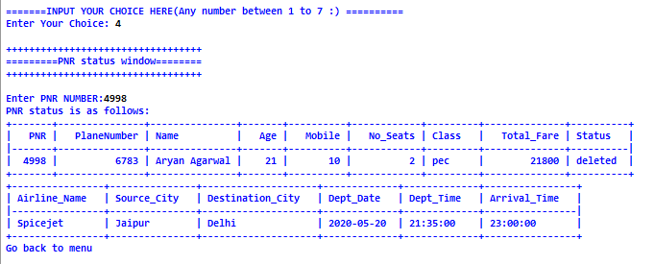

When the user chooses “5” they are shown details of all the flights in a database:

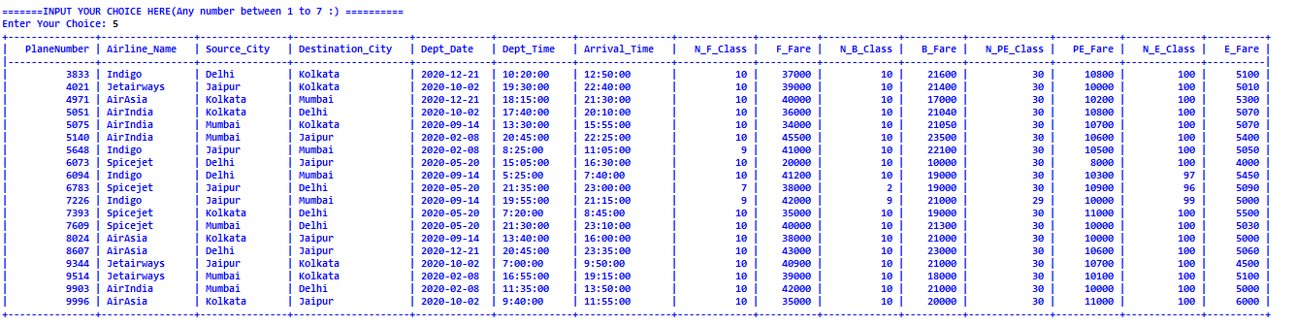

When the user chooses “6” the following popularity graph is displayed:

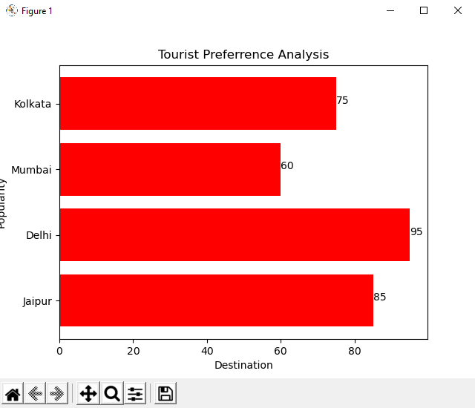

When the user chooses “7” the program stops running:

When the user chooses “8” and “9”the following dataframes are displayed which have been turned into CSV files:

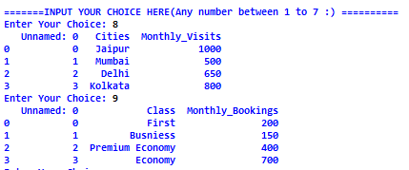

**6. SOURCE CODE FOR THE PROJECT**

**# Command to import the module**

import mysql.connector

from tabulate import tabulate

import random

import matplotlib.pyplot as plt

import pandas as pd

**# Command to connect database**

mydb=mysql.connector.connect(host="localhost",port='3307',user="root",passwd="root",database="myairport")

**# Command to create a cursor to access the data from the python program**

mycursor=mydb.cursor()

**# Command to define the function to display the main menu**

def airesmenu():

print(" ___ ")

print(" \\ \ ")

print(" \\ `\ ")

print(" ___ \\ \ ")

print(" | \ \\ `\ ")

print(" |_____\ \ \ ")

print(" |______\ \ `\ ")

print(" | \ \ \ ")

print(" | __\__---------------------------------._. ")

print(" __|---~~~__o_o_o_o_o_o_o_o_o_o_o_o_o_o_o_o_o_o_[][\__ ")

print("|___ /~ ) \__ ")

print(" ~~~---..._______________/ ,/_________________/ ")

print(" / / ")

print(" / ,/ ")

print(" / / ")

print(" / ,/ ")

print(" / / ")

print(" // ,/ ")

print(" // / ")

print(" // ,/ ")

print(" //__/ ")

print()

print("++++++++++++++++++++++++++++++++++++++++++++++++++++++++++++++++++")

print("============== WELCOME IN AIRLINE RESERVATION SYSTEM =============")

print("*****************************MAIN MENU****************************")

print("++++++++++++++++++++++++++++++++++++++++++++++++++++++++++++++++++")

print()

print("AIRLINE RESERVATION SYSTEM")

print("1.Search Flight Details")

print("2.Reservation of Ticket")

print("3.Cancellation of Ticket")

print("4.Display PNR Status")

print("5.Display All Flight Details")

print("6.Show Popularity Graph")

print("7.Quit")

print("8.See the CSV_1[for testing]")

print("9.See the CSV_2[for testing]")

print("",end="\n")

print("=======INPUT YOUR CHOICE HERE(Any number between 1 to 9 :) ==========")

ch='y'

while(ch=='y'):

n=input("Enter Your Choice: ")

if (not any(char.isdigit() for char in n)):

print('choice should have any number between 1 to 9 :')

ch='n'

else:

n=int(n)

if(n==1):

flight_search()

ch='n'

elif(n==2):

flight_reservation()

ch='n'

elif(n==3):

flight_cancel()

ch='n'

elif(n==4):

flight_PNR_status()

ch='n'

elif(n==5):

all_flight_details()

ch='n'

elif(n==6):

ch='n'

dest=['Jaipur','Delhi','Mumbai', 'Kolkata']

pop=[85,95,60,75]

plt.barh(dest,pop,align='center',color='red')

for index, value in enumerate(pop):

plt.text(value, index, str(value))

plt.xlabel('Destination')

plt.ylabel('Popularity')

plt.title('Tourist Preferrence Analysis')

plt.show()

print("Go back to menu")

print('\n'*10)

print("==============================================================================================")

airesmenu()

airesmenu()

elif(n==7):

exit(0)

elif(n==8):

ch='n'

CSV_frame= pd.DataFrame({'Cities':['Jaipur','Mumbai','Delhi','Kolkata'],'Monthly_Visits':[1000,500,650,800]})

CSV_frame.to_csv("C:\\Users\\mukesh\\Desktop\\City Popularity Chart.csv")

CSV_read= pd.read_csv("C:\\Users\\mukesh\\Desktop\\City Popularity Chart.csv")

print(CSV_read)

print("Go back to menu")

print('\n'*10)

print("==============================================================================================")

airesmenu()

airesmenu()

elif(n==9):

ch='n'

CSV_frame2= pd.DataFrame({'Class':['First','Busniess','Premium Economy','Economy'],'Monthly_Bookings':[200,150,400,700]})

CSV_frame2.to_csv("C:\\Users\\mukesh\\Desktop\\Class Popularity Chart.csv")

CSV_read2= pd.read_csv("C:\\Users\\mukesh\Desktop\\Class Popularity Chart.csv")

print(CSV_read2)

print("Go back to menu")

print('\n'*10)

print("==============================================================================================")

airesmenu()

airesmenu()

else:

print("wrong choice")

ch='y'

def flight_search():

print("Search Flights")

print()

print("++++++++++++++++++++++++++++++++++")

print("=========Flight Search Window========")

print("++++++++++++++++++++++++++++++++++")

print()

**# Command to ask passenger for their source city and Destination city**

S_City=input("Enter Source City:")

D_City=input("Enter Destination City:")

**# Command to display flight details from table in the MySQL database**

sql="select PlaneNumber,Airline_Name,Source_City,Destination_City,Dept_Date,Dept_Time, Arrival_Time,N_F_Class,F_Fare,N_B_Class,B_Fare, N_PE_Class, PE_Fare, N_E_Class, E_Fare from airdetails where Source_City=%s AND Destination_City=%s"

val=(S_City,D_City,)

mycursor.execute(sql,val)

res=mycursor.fetchall()

mydb.commit()

if not res:

print("please enter correct source and destination city !! ")

else:

print("Flight status is as follows:")

**# Command to display the information related to the pnr from the table**

print(tabulate(res, headers=['PlaneNumber','Airline_Name','Source_City','Destination_City','Dept_Date','Dept_Time', 'Arrival_Time','N_F_Class','F_Fare','N_B_Class','B_Fare', 'N_PE_Class', 'PE_Fare', 'N_E_Class', 'E_Fare'], tablefmt='psql'))

print("Go back to menu")

print('\n'*10)

print("==============================================================================================")

airesmenu()

airesmenu()

def flight_reservation():

global pnr

l1=[]

print()

print("+++++++++++++++++++++++++++++++")

print("===Ticket Reservation Window===")

print("+++++++++++++++++++++++++++++++")

print()

ques=int(input("Do you know Flight Details type 1 for YES and 0 for NO : "))

if (ques==0):

flight_search()

elif (ques==1):

**# Command to calculate pnr of the user**

pnr=random.randint(0,10000)

l1.append(pnr)

**# Command to ask user the plane number**

planeno=int(input("Enter plane number="))

l1.append(planeno)

**# Command to ask for the name of passenger**

p_name=input("Enter passenger name=")

if p_name.isdigit():

print("Enter valid name in alphabets")

airesmenu()

else:

l1.append(p_name)

**# Command to ask user for age of passenger**

age=input("Enter age of passenger=")

if age.isdigit():

age=int(age)

if (age>1 and age<150):

l1.append(age)

else:

print("Please write valid age in integer")

airesmenu()

else:

print("Please write valid age in integer")

airesmenu()

**# Command to ask user mobile number**

mobile=input("Enter Mobile Number of passenger=")

if mobile.isdigit():

#mobile=int(mobile)

n=len(mobile)

if (n>0 and n<11):

l1.append(n)

else:

print("Please write valid mobile number ")

airesmenu()

else:

print("Please write valid mobile number ")

airesmenu()

#payment options

**# Command to ask user for the number of passengers**

noofpas=int(input("Enter number of passengers:"))

l1.append(noofpas)

**# Command to ask user for the class they would like to travel in**

print("Select a class you would like to travel in")

print("1.FIRST CLASS")

print("2.BUSINESS CLASS")

print("3.PREMIUM ECONOMY CLASS")

print("4.ECONOMY CLASS")

cp=int(input("Enter your choice:"))

**# Command to calculate the amount to be paid by the user according to their choices**

rplane_no=(planeno,)

if(cp==1):

sql="select N_F_Class from airdetails where PlaneNumber=%s"

mycursor.execute(sql,rplane_no)

nfseats=mycursor.fetchone()

if nfseats is None:

nfseats=0;

print("you have entered incorrect plane number..please try again")

airesmenu()

else:

nfseats=int(nfseats[0])

if(nfseats>=noofpas):

sql="select F_Fare from airdetails where PlaneNumber=%s"

mycursor.execute(sql,rplane_no)

ffare=mycursor.fetchone()

ffare=int(ffare[0])

amt=noofpas*ffare

cls='fc'

updated_seats=nfseats-noofpas

sql= "Update airdetails SET N_F_Class =%s where PlaneNumber=%s"

data=(updated_seats,planeno,)

mycursor.execute(sql,data)

mydb.commit()

else:

print("Sufficient Number of seats are not available...please search again")

airesmenu()

elif(cp==2):

sql="select N_B_Class from airdetails where PlaneNumber=%s"

mycursor.execute(sql,rplane_no)

nbseats=mycursor.fetchone()

if nbseats is None:

nbseats=0;

print("you have entered incorrect plane number..please try again")

airesmenu()

else:

nbseats=int(nbseats[0])

if(nbseats>=noofpas):

sql="select B_Fare from airdetails where PlaneNumber=%s"

mycursor.execute(sql,rplane_no)

bfare=mycursor.fetchone()

bfare=int(bfare[0])

amt=noofpas*bfare

cls='bc'

updated_seats=nbseats-noofpas

sql= "Update airdetails SET N_B_Class =%s where PlaneNumber=%s"

data=(updated_seats,planeno,)

mycursor.execute(sql,data)

mydb.commit()

else:

print("Sufficient Number of seats are not available...please search again")

airesmenu()

elif(cp==3):

sql="select N_PE_Class from airdetails where PlaneNumber=%s"

mycursor.execute(sql,rplane_no)

npeseats=mycursor.fetchone()

if npeseats is None:

npeseats=0;

print("you have entered incorrect plane number..please try again")

airesmenu()

else:

npeseats=int(npeseats[0])

if(npeseats>=noofpas):

sql="select PE_Fare from airdetails where PlaneNumber=%s"

mycursor.execute(sql,rplane_no)

pefare=mycursor.fetchone()

pefare=int(pefare[0])

amt=noofpas*pefare

cls='pec'

updated_seats=npeseats-noofpas

sql= "Update airdetails SET N_PE_Class =%s where PlaneNumber=%s"

data=(updated_seats,planeno,)

mycursor.execute(sql,data)

mydb.commit()

else:

print("Sufficient Number of seats are not available...please search again")

airesmenu()

elif(cp==4):

sql="select N_E_Class from airdetails where PlaneNumber=%s"

mycursor.execute(sql,rplane_no)

neseats=mycursor.fetchone()

if neseats is None:

neseats=0;

print("you have entered incorrect plane number..please try again")

airesmenu()

else:

neseats=int(neseats[0])

if(neseats>=noofpas):

sql="select E_Fare from airdetails where PlaneNumber=%s"

mycursor.execute(sql,rplane_no)

efare=mycursor.fetchone()

efare=int(efare[0])

amt=noofpas*efare

cls='ec'

updated_seats=neseats-noofpas

sql= "Update airdetails SET N_E_Class =%s where PlaneNumber=%s"

data=(updated_seats,planeno,)

mycursor.execute(sql,data)

mydb.commit()

else:

print("Sufficient Number of seats are not available...please search again")

airesmenu()

else:

print("You have selected wrong class!!")

airesmenu()

l1.append(cls)

**# Command to display the total amount to be paid by the user**

print("total amount to be paid:",amt)

l1.append(amt)

**# Command to display the pnr of the passenger**

#print("PNR number:",pnr)

#print("status:confirmed")

status='confirmed'

l1.append(status)

reservation=(l1)

print("Please pay the amount to get the ticket!!!!")

pay=int(input("Enter 1 to print the ticket, 0 to save the paper:"))

**# Command to insert the information obtained from user in the table in database**

if(pay==1):

sql="insert into reservation_details(PNR,PlaneNumber,Name,Age,Mobile,No_Seats,Class,Total_Fare,Status)values(%s,%s,%s,%s,%s,%s,%s,%s,%s)"

mycursor.execute(sql,reservation)

mydb.commit()

print("please get your ticket:" )

mypnr=(pnr,)

sql="select * from reservation_details where PNR=%s"

mycursor.execute(sql,mypnr)

ticketdetail=mycursor.fetchall()

mydb.commit()

print(tabulate(ticketdetail, headers=['PNR','PlaneNumber','Name','Age','Mobile','No_Seats','Class','Total_Fare','Status'], tablefmt='psql'))

elif(pay==0):

print("You have saved the paper...THANKS")

else:

print("wrong choice")

ch='y'

print("Go back to menu")

print('\n'*10)

print("==============================================================================================")

else:

print("wrong choice")

ch='y'

airesmenu()

airesmenu()

**# Command to define function to cancel a ticket**

def flight_cancel():

print()

print("++++++++++++++++++++++++++++++++++++++++++++++++++++++++++++++++++++++++")

print("======================Ticket cancellation window========================")

print("++++++++++++++++++++++++++++++++++++++++++++++++++++++++++++++++++++++++")

print()

**# Command to ask the passenger for the pnr for which the ticket has to be cancelled**

pnr=input("Enter PNR for cancellation of ticket:")

pn=(pnr,)

**# Command to update the status of pnr in the MySQL table**

sql_cancel="select PlaneNumber, No_Seats, Class from reservation_details where PNR=%s"

mycursor.execute(sql_cancel,pn)

tktdetails=mycursor.fetchone()

print(tktdetails)

myplaneno=int(tktdetails[0])

myseats=int(tktdetails[1])

myclass=tktdetails[2]

if(myclass=="fc"):

sql= "Update airdetails SET N_F_Class =N_F_Class + %s where PlaneNumber=%s"

elif(myclass=="bc"):

sql= "Update airdetails SET N_B_Class =N_B_Class + %s where PlaneNumber=%s"

elif(myclass=="pec"):

sql= "Update airdetails SET N_PE_Class =N_PE_Class + %s where PlaneNumber=%s"

elif(myclass=="ec"):

sql= "Update airdetails SET N_E_Class =N_E_Class + %s where PlaneNumber=%s"

else:

print("Please enter correct PNR Number and Try Again")

airesmenu()

data=(myseats,myplaneno,)

mycursor.execute(sql,data)

mydb.commit()

sql="update reservation_details set status='deleted' where PNR=%s"

mycursor.execute(sql,pn)

mydb.commit()

print("Ticket Cancellation has completed")

print("Go back to menu")

print('\n'*10)

print("=============================================================================================")

airesmenu()

#airesmenu()

**# Command to describe the function to display the status of a pnr**

def flight_PNR_status():

print()

print("++++++++++++++++++++++++++++++++++")

print("=========PNR status window========")

print("++++++++++++++++++++++++++++++++++")

print()

**# Command to ask passenger for their pnr**

pnr=input("Enter PNR NUMBER:")

pn=(pnr,)

**# Command to select the status of pnr from table in the MySQL database**

sql="select * from reservation_details where PNR=%s"

mycursor.execute(sql,pn)

res=mycursor.fetchall()

mydb.commit()

print("PNR status is as follows:")

print(tabulate(res, headers=['PNR','PlaneNumber','Name','Age','Mobile','No_Seats','Class','Total_Fare','Status'], tablefmt='psql'))

#print other details

sql="select PlaneNumber from reservation_details where PNR=%s"

mycursor.execute(sql,pn)

planeno=mycursor.fetchone()

sql="select Airline_Name,Source_City,Destination_City,Dept_Date,Dept_Time, Arrival_Time from airdetails where PlaneNumber=%s"

mycursor.execute(sql,planeno)

res1=mycursor.fetchall()

mydb.commit()

print(tabulate(res1, headers=['Airline_Name','Source_City','Destination_City','Dept_Date','Dept_Time', 'Arrival_Time'], tablefmt='psql'))

print("Go back to menu")

print('\n'*10)

print("==============================================================================================")

airesmenu()

**#command to display all flight details**

def all_flight_details():

sql="select * from airdetails"

mycursor.execute(sql)

rows=mycursor.fetchall()

print(tabulate(rows, headers=['PlaneNumber','Airline_Name','Source_City','Destination_City','Dept_Date','Dept_Time', 'Arrival_Time','N_F_Class','F_Fare','N_B_Class','B_Fare', 'N_PE_Class', 'PE_Fare', 'N_E_Class', 'E_Fare'], tablefmt='psql'))

airesmenu()

airesmenu()

**7. Data Dictionary**

**Various tables used in this project are as follows:**

|  |  |  |
| --- | --- | --- |
| S # | Table Name | Uses |
| 1 | Airdetails | to store the airplane details |
| 2 | Reservationdetails | to store the PNR status of flights |
|  |  |  |

**AIRDETAILS**

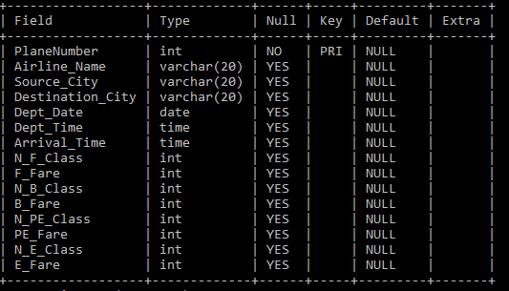

**AIRPLANE DETAILS**

